AutoEmail Send Window Tests
Tester: Tony Tasker
Date: 2nd November 2016
Time: 15:00
PC/Server: TonyTasker-PC
Database: CABS_TEST (Copy of SHU DB)
Works Summary: N/A
Works Order: N/A
Task: N/A
Notes:
Pre-Test Setup
No | Task | Tester | Pass | Notes
1 | Ensure records exist in AEF_LINK to test  SELECT COUNT(*) FROM AEF_Link | TT |  | Returned 42
2 | In section CABS_AUTO_EMAIL_FUNCS_Trigger  Set DebugFlag=1 | TT

Post-Test Setup
No | Task | Tester | Pass | Notes
1 | In section CABS_AUTO_EMAIL_FUNCS_Trigger  Set DebugFlag=0 | TT
2 | In section AEFCON  StartWindow=dd/mm/yyyy  WindowDuration=xx  ResetDuration=x  Remove test config | TT

Tests

SendWindow Functionality Ignored If No Config Settings
No | Test | Tester | Pass | Notes
1 | Ensure that config:  StartWindow=dd/mm/yyyy  WindowDuration=xx  ResetDuration=x  does not exist for email template AEFCON | TT
2 | Update an autoemail to get it to a send state  UPDATE FUNC_FIL SET F_STATUS = 'CONFRM' WHERE F_REF = 'F118790'  Check Email is Sendable  SELECT * FROM vw_AEFLINK WHERE AEFL_EmailType = 'AEFCON' and AEFL_FREF = 'F118790'  Run stored procedure  EXEC CABS_AUTO_EMAIL_FUNCS_SESS_CHECK | TT |  | Use diagnostic information in code to test.  Check Messages TAB in SQL Manager  Messages indicating SendWindow is not configured should be displayed for email AEFCON.  See results in figure below.

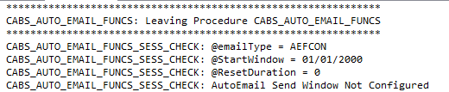
Figure 1 – SendWindow Functionality Ignored

SendWindow In Past – SendWindow Updated
No | Test | Tester | Pass | Notes
1 | Ensure that config is designed to ensure that StartWindow + ResetDuration is in past:  StartWindow=25/10/2016  WindowDuration=10  ResetDuration=5  exists for email template AEFCON | TT
2 | Update an autoemail to get it to a send state  UPDATE FUNC_FIL SET F_STATUS = 'CONFRM' WHERE F_REF = 'F118790'  Check Email is Sendable  SELECT * FROM vw_AEFLINK WHERE AEFL_EmailType = 'AEFCON' and AEFL_FREF = 'F118790'  Run stored procedure  EXEC CABS_AUTO_EMAIL_FUNCS_SESS_CHECK | TT |  | Use diagnostic information in code to test.  Check Messages TAB in SQL Manager  Messages indicating SendWindow is updated should be displayed for email AEFCON and X CABS Config should be updated.  See results in figures below.

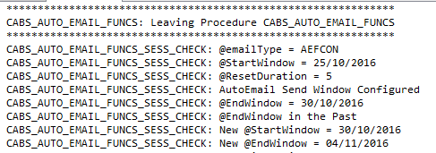
Figure 2 – SendWindow Updated
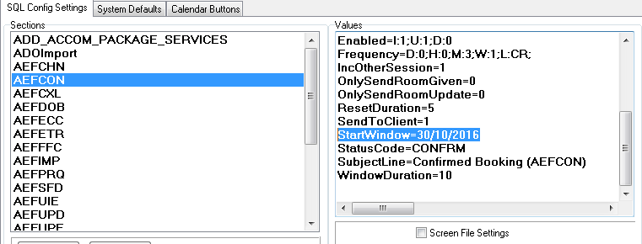
Figure 3 - X CABS Config with Updated StartWindow

SendWindow Current
No | Test | Tester | Pass | Notes
1 | Should be set as per previous test for email template AEFCON  StartWindow=30/10/2016  WindowDuration=10  ResetDuration=5 | TT
2 | Update an autoemail to get it to a send state  UPDATE FUNC_FIL SET F_STATUS = 'CONFRM' WHERE F_REF = 'F118790'  Check Email is Sendable  SELECT * FROM vw_AEFLINK WHERE AEFL_EmailType = 'AEFCON' and AEFL_FREF = 'F118790'  Run stored procedure  EXEC CABS_AUTO_EMAIL_FUNCS_SESS_CHECK | TT |  | Use diagnostic information in code to test.  Check Messages TAB in SQL Manager  Messages indicating SendWindow configuration should be displayed for email AEFCON.  See results in figure below.

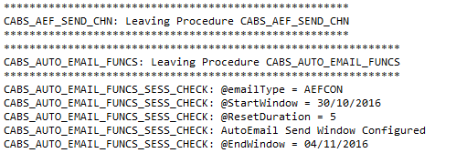
Figure 4 – SendWindow Current

Changed Function but no SendWindow Configured
No | Test | Tester | Pass | Notes
1 | Ensure that config:  StartWindow=dd/mm/yyyy  WindowDuration=xx  ResetDuration=x  does not exist for email template AEFCON  Update an autoemail to get it to a send state:  UPDATE FUNC_FIL SET F_STATUS = 'CONFRM' WHERE F_REF = 'F118790' | TT |  | Function Date: 04/07/2018
2 | Ensure that function  SELECT dbo.[uf_AEF_Is_Within_Send_Window] ('F118790', 'AEFCON')  Returns 1 | TT |  | A return value of 1 means that SendWindow functionality is not affecting email transmission
3 | Ensure that function  SELECT dbo.[uf_AEF_Link_Sendable] ('F118790', 'AEFCON')  Returns 1 | TT |  | A return value of 1 means that the email is Sendable (which incorporates SendWind functionality)

Changed Function – SendWindow Configured – Function Date Outside of SendWindow
No | Test | Tester | Pass | Notes
1 | Ensure that config:  StartWindow=01/11/2016  WindowDuration=10  ResetDuration=5  does exists for email template AEFCON  Update an autoemail to get it to a send state:  UPDATE FUNC_FIL SET F_STATUS = 'CONFRM' WHERE F_REF = 'F118790' | TT |  | Function Date: 04/07/2018
2 | Check Function Day is outside of SendWindow  SELECT AEFL_FDAY FROM AEF_Link WHERE AEFL_FREF = 'F118790' AND AEFL_EmailType = 'AEFCON'  Ensure that function  SELECT dbo.[uf_AEF_Is_Within_Send_Window] ('F118790', 'AEFCON')  Returns 0 | TT |  | A return value of 0 means that SendWindow functionality is affecting email transmission – email will not be transmitted
3 | Ensure that function  SELECT dbo.[uf_AEF_Link_Sendable] ('F118790', 'AEFCON')  Returns 0 | TT |  | A return value of 0 means that the email is not Sendable (which incorporates SendWind functionality)

Changed Function – SendWindow Configured – Function Date Inside of SendWindow
No | Test | Tester | Pass | Notes
1 | Ensure that config:  StartWindow=01/11/2016  WindowDuration=10  ResetDuration=5  does exists for email template AEFCON  Ensure Function Date is in future:  UPDATE AEF_LINK SET AEFL_FDAY = '2016-11-04 09:0:00' WHERE AEFL_FREF = 'F119341'  Update an autoemail to get it to a send state:  UPDATE FUNC_FIL SET F_STATUS = 'CONFRM' WHERE F_REF = 'F119341' | TT |  | Function Date: 04/11/2016
2 | Check Function Day is inside of SendWindow  SELECT AEFL_FDAY FROM AEF_Link WHERE AEFL_FREF = 'F119341' AND AEFL_EmailType = 'AEFCON'  Ensure that function  SELECT dbo.[uf_AEF_Is_Within_Send_Window] ('F119341', 'AEFCON')  Returns 1 | TT |  | A return value of 1 means that SendWindow functionality is affecting email transmission – email will be transmitted
3 | Ensure that function  SELECT dbo.[uf_AEF_Link_Sendable] ('F118790', 'AEFCON')  Returns 1 | TT |  | A return value of 1 means that the email is Sendable (which incorporates SendWind functionality)

